ETL Project: Craft Beers

**Project scope:**

Creating a relational database in order to obtain all addresses for craft beer breweries in the United States. For those traveling, other areas of the world are available as well.

# **E**xtract:

**Data Sources:**

We derived data from 2 sources, <https://www.kaggle.com/ritesaluja/beer-beer-beer/data> (Beer-beer-beer. csv) this contains the address of Craft breweries across the world, beer name and style this contains name, Beers types, styles and other related data. <https://www.kaggle.com/nickhould/craft-cans#beers.csv> (Craft Beers Data set.csv). this contains name, Beers types, styles and other related data. Both files are in a CSV format for Ease of modification. Once cleaned of extraneous data in Python they will each be loaded in to PostgressSQL so they can be queried in a structured data base

**Beer-beer-beer**: Initially contained the following columns: Name, id, brewery_id, cat_id, style_id, Alcohol By Volume, International Bitterness Units, Standard Reference Method, Universal Product Code, filepath, Description, add_user, last_mod, Style, Category, Brewer, Address, City, State

Once cleaned in Python it will contain the following columns: Name, Brewer, brewery_id, id, Address, City, State, Country

**Craft Beers Data set**: initially contained the following columns: abv, ibu, id, name, style, brewery_id, ounces

Once cleaned in Python it will contain (We decided to not remove any columns): name, style, brewery_id, id, abv, ibu, ounces

# **T**ransform:

During this process that following will be done:

Duplicates removed for both files using Python; it was found that Multiple records exists containing the same data: Learning experience

Kept receiving duplicates and realized when ordering column names, it was converting back to original spreadsheet instead of the removed duplicates. Reordered and corrected the issue.

Extraneous Columns were removed from Beer-beer-beer data set: , cat_id, style_id, Alcohol By Volume, International Bitterness Units, Standard Reference Method, Universal Product Code, filepath, Description, add_user, last_mod. These columns are either duplicate or not needed in final data set

Reorganized column names via python

Removed initial index via python as it was giving incorrect information when doing searches on the database table

Also eliminated rows that contained non-ASCII (funny) characters as well as rows with corrupt or non-integer id fields.

Removed Primary key due to Multiple beers having the same name and it was causing constraint issues when loading the table(s)

# **L**oad:

Loaded final data frame from pandas into postgres tables.

Pulled various queries for data check

ERD:

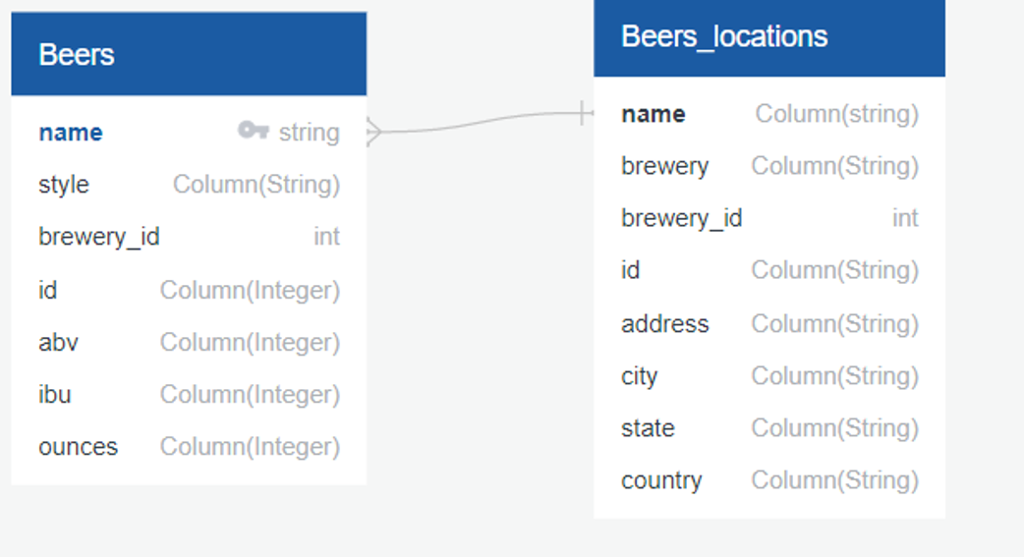

Query of US breweries

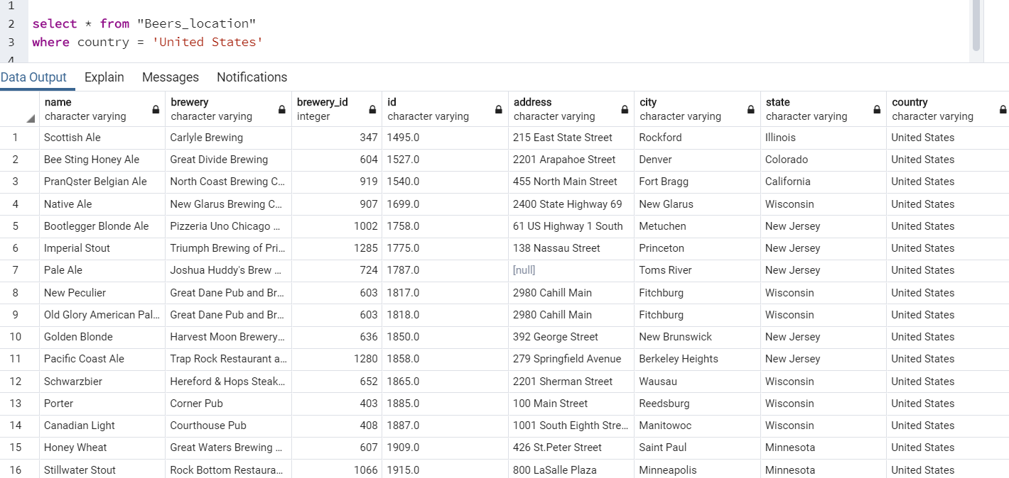

All breweries

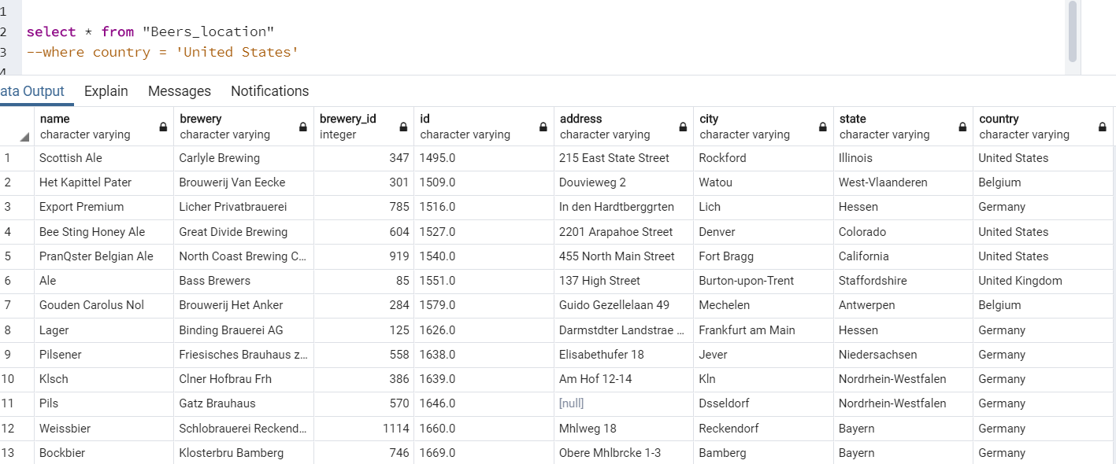

Columns

